William Pulkownik

25 NOV 2019

Database Systems

Final Project Proposal

For my Final Project I am proposing a personal library system. I have many books which I have no system for tracking. Essentially I would like to develop a catalog to track:

\* what books are in my system

\* book details (author, year, genre, title)

\* reader details

\* whether the reader owns the book and short review notes

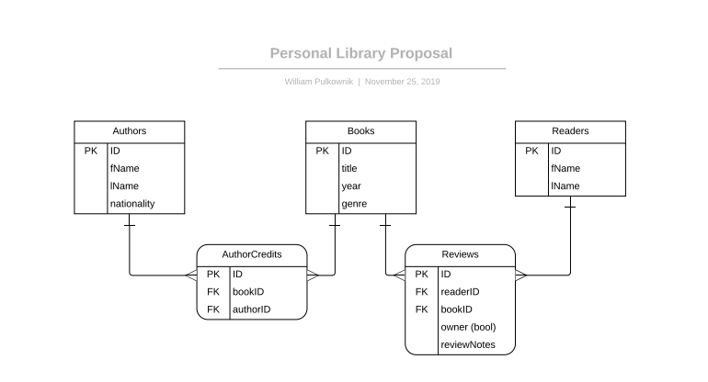Basically this will allow me to track the books I’ve read and books I have yet to read, but it will also allow me to chart books I’d like to read and (if a friend owns it) who might have it. I have plenty of books and It will also allow me to track the reading of my books across time with different reviews.